|  |
| --- |
| SPARK FOUNDATION |
| COMPARISON OF CLOUD SERVICE PROVIDERS |
|  |

|  |
| --- |
| Neha Borole  [Date] |

Cloud Computing Services

Cloud computing is a subscription-based service where you can obtain networked storage space and computer resources. The cloud makes it possible for you to access information from anywhere. Cloud provider can both own and house the hardware and software necessary to run your house or office applications.

There are many types of cloud available which can subscribe according to your need.

* Public Cloud: It can be accessed by any subscriber with an internet connection
* Private Cloud: It can be accessed by specific group or specific organization, limits access to that group.
* Community Cloud: it is shared among two or more organizations that has similar cloud requirement
* Hybrid Cloud: it is combination of two clouds which can be either public or private or community cloud.

There are three types of service providers that you can subscribe to

* Software as Service: In this, provider gives subscribers access to both resources and application. In Saas you have least control over cloud.
* Platform as Service: In this, provider gives access to the components that require to develop and operate applications over the internet.
* Infrastructure as Service: it deals with primarily with computational infrastructure. Subscriber completely outsources the storage and resources such as hardware and software as they need.

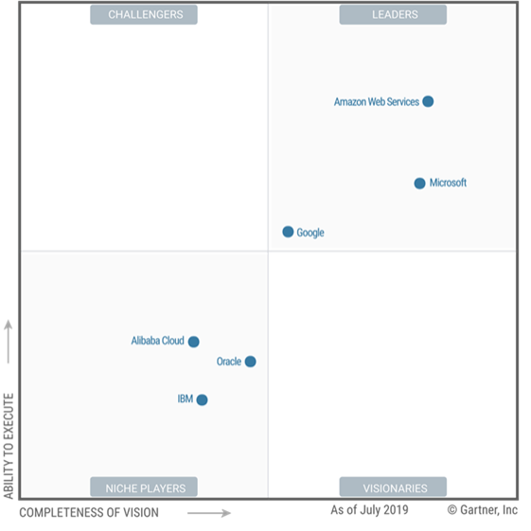

Figure 1. Magic Quadrant for Cloud Infrastructure as Service, Worldwide

According to magic quadrant for cloud infrastructure, Amazon AWS leads Microsoft and google cloud in Iaas position. The PaaS component of cloud computing offers a full development and deployment environment in the cloud, including dev, test, QA, debugging, and deployment tools and services. SaaS is a software developed and hosted by someone else. Businesses or individuals are able to use them as needed.

Top cloud service providers

Majority of top service providers offer all of these services. The two leaders in cloud computing are Amazon AWS and Microsoft Azure followed by Google, Alibaba and IBM.

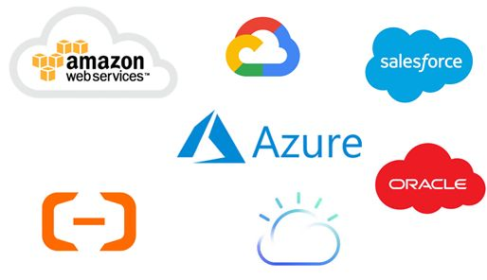

Here is list of top cloud computing service provider:

1. Amazon web services
2. Microsoft Azure
3. Google Cloud
4. Alibaba Cloud
5. IBM Cloud
6. Oracle
7. Salesforce
8. Sap
9. Rackspace Cloud
10. VMware

|  |  |  |  |  |  |
| --- | --- | --- | --- | --- | --- |
| Company | AWS | AZURE | Google Cloud | Alibaba Cloud | Oracle Cloud |
| Launch year | 2006 | 2010 | 2008 | 2009 | 2012 |
| Geographical Region | 24 | 60 | 22 | 19 | 19 |
| Availability zones | 78 | 140 | 61 | 63 | 27 |
| Key offerings | Compute, storage, database, analytics, networking, machine learning, and AI, mobile, developer tools, IoT, security, enterprise applications, blockchain. | Compute, storage, mobile, data management, messaging, media services, CDN, machine learning and AI, developer tools, security, blockchain, functions, IoT. | Compute, storage, databases, networking, big data, cloud AI, management tools, Identity and security, IoT, API platform | Elastic Compute,  Storage,  Pay as you go basis,  Data storage,  Relational Database,  Big data processing,  Anti D dos protection,  Content delivery Networks | Compute,  Storage,  Networking, connectivity  And edge  Services,  Security,  Identity,  Compliance  Database Management,  Analytics  And big data  Management |
| Compliance certificates | 46 | 90 | 55 | 24 | 41 |
| Annual Revenue | $33 billion | $35 billion | $8 billion | $4.5 billion | $40 billion |

Comparison between various cloud computing providers

Working with Amazon AWS cloud service Provider

Amazon web service provides reliable, scalable and inexpensive cloud computing services. It is most secure, extensive platform. Benefits of Amazon web services

* Security: - All data flowing across the AWS global network that interconnects their datacentres and Regions is automatically encrypted at the physical layer before it leaves their secured facilities.
* Availability: - AWS delivers the highest network availability of any cloud provider, with 7x fewer down time hours than the next largest cloud provider.
* Performance: - The AWS Global Infrastructure is built for performance. AWS Regions offer low latency, low packet loss, and high overall network quality. This is achieved with a fully redundant 100 GbE fiber network backbone, often providing many terabits of capacity between Regions.
* Global Footprint: -AWS has the largest global infrastructure footprint of any provider, and this footprint is constantly increasing at a significant rate. When deploying your applications and workloads to the cloud, you have the flexibility in selecting a technology infrastructure that is closest to your primary target of users. You can run your workloads on the cloud that delivers the best support for the broadest set of applications, even those with the highest throughput and lowest latency requirements.
* Scalability: - The AWS Global Infrastructure enables companies to be extremely flexible and take advantage of the conceptually infinite scalability of the cloud. Customers used to over provision to ensure they had enough capacity to handle their business operations at the peak level of activity.
* Flexibility: - The AWS Global Infrastructure gives you the flexibility of choosing how and where you want to run your workloads, and when you do you are using the same network, control plane, API’s, and AWS services.

.

REFERENCES

1.AmazonAWSwebsite<https://aws.amazon.com/about-aws/globainfrastructure/?pg=WIAWS-N&tile=learn_more>

2. <https://www.c-sharpcorner.com/article/top-10-cloud-service-providers/>